1. **Gantt Chart**

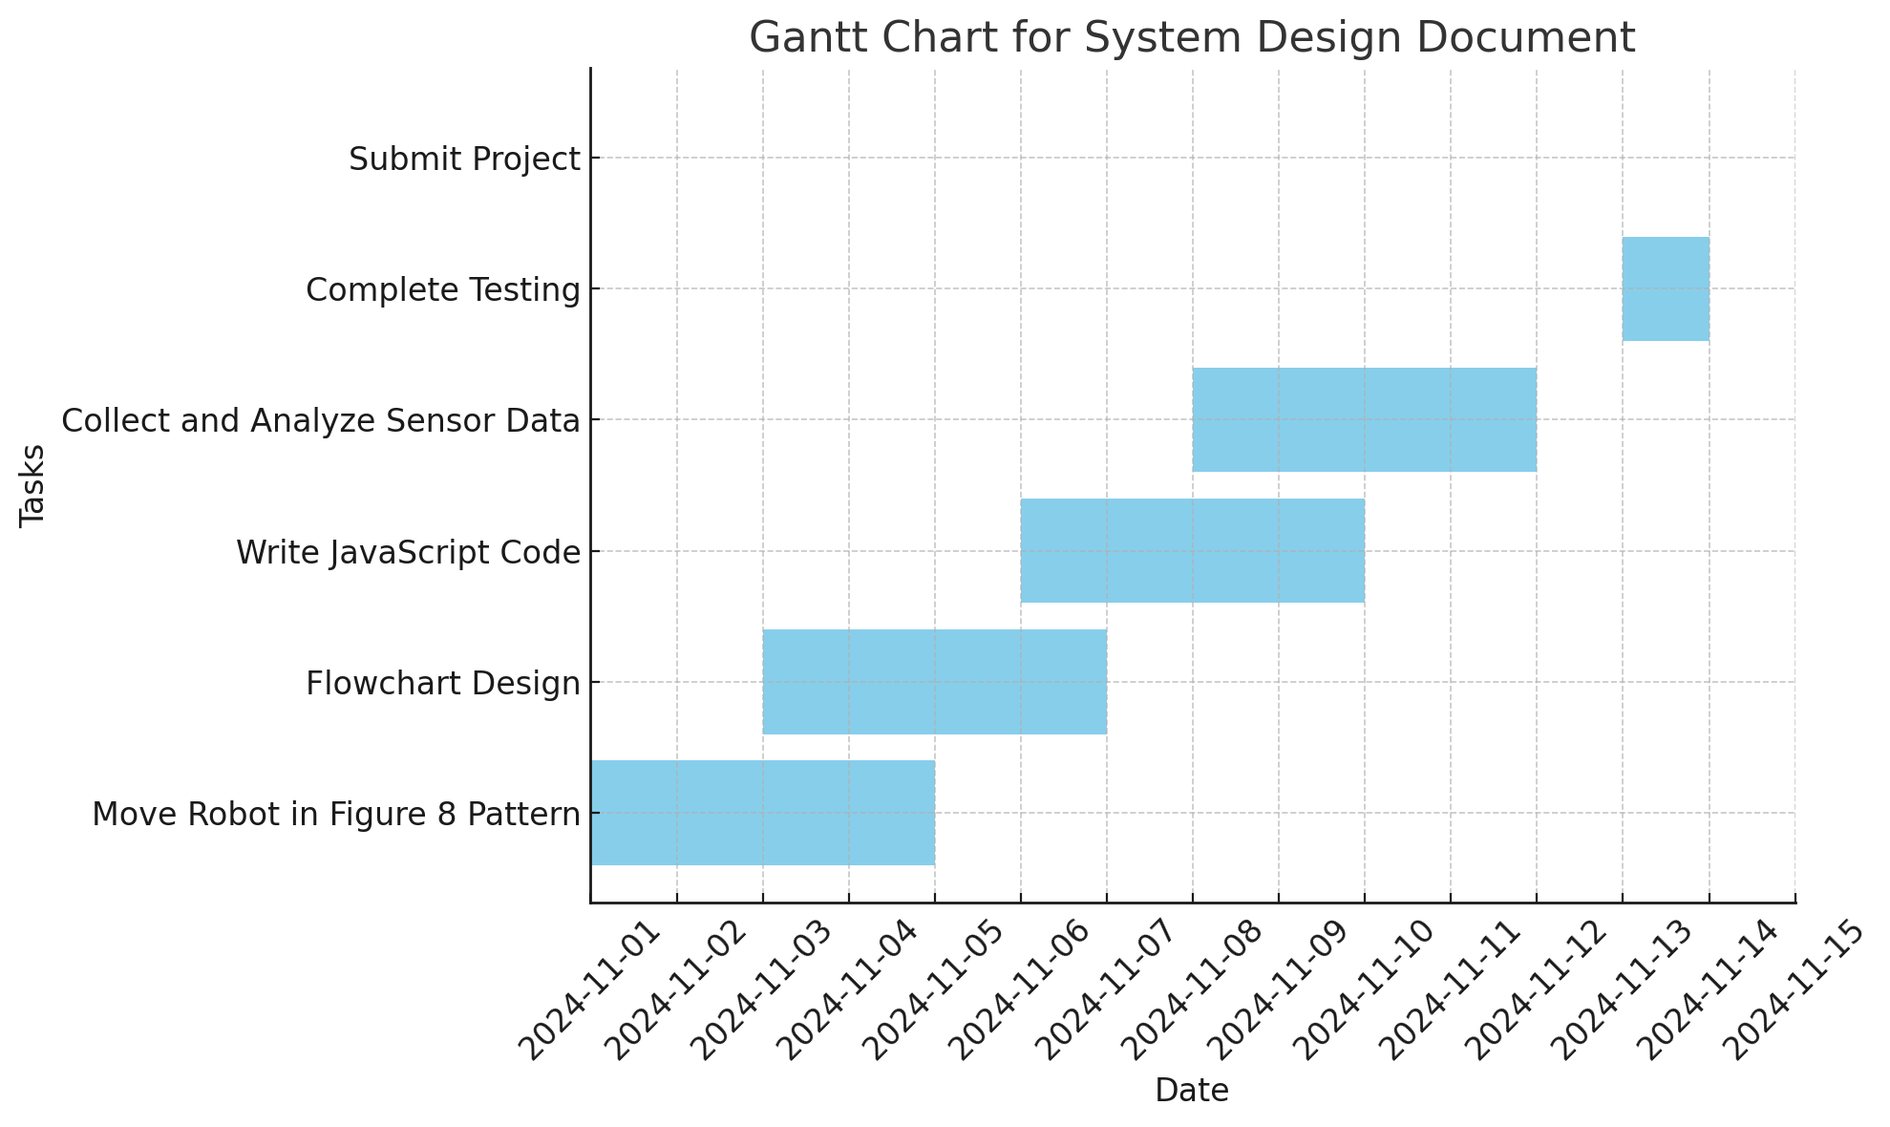

1. **Requirements Table**

| **Requirement ID** | **Description** | **Status** |
| --- | --- | --- |
| R1 | Robot must move in a figure 8 patter | Complete |
| R2 | Flowchart must match the algorithm steps | Complete |
| R3 | Javascript code must drive the Sphero Bolt | Complete |
| R4 | Sensor data must be collected and analyzed | Complete |

1. **Requirments Signoff Table**

| **Requirement ID** | **Signoff By** | **Date** |
| --- | --- | --- |
| R1 | Isaac and Bilal | 11/15/24 |
| R2 | Isaac and Bilal | 11/15/24 |
| R3 | Isaac and Bilal | 11/15/24 |
| R4 | Isaac and Bilal | 11/15/24 |

1. **Algorithm**
2. Initialize speed to 100.
3. Initialize duration to 0.2.
4. Initialize delayTime to 0.05.
5. Initialize angleStep to 10.
6. Set i to 0 (start of loop).
7. Calculate angle = 360 - i * angleStep.
8. Call roll(angle, speed, duration).
9. Wait for roll to complete.
10. Call delay(delayTime).
11. Wait for delay to complete.
12. Increment i by 1.
13. Check if i < 36. If true, go back to Step 6; otherwise, continue.
14. Set i to 0 (start of loop).
15. Calculate angle = i * angleStep.
16. Call roll(angle, speed, duration).
17. Wait for roll to complete.
18. Call delay(delayTime).
19. Wait for delay to complete.
20. Increment i by 1.
21. Check if i < 36. If true, go back to Step 14; otherwise, continue.
22. Program ends after completing both loops.
23. **Flowchart**

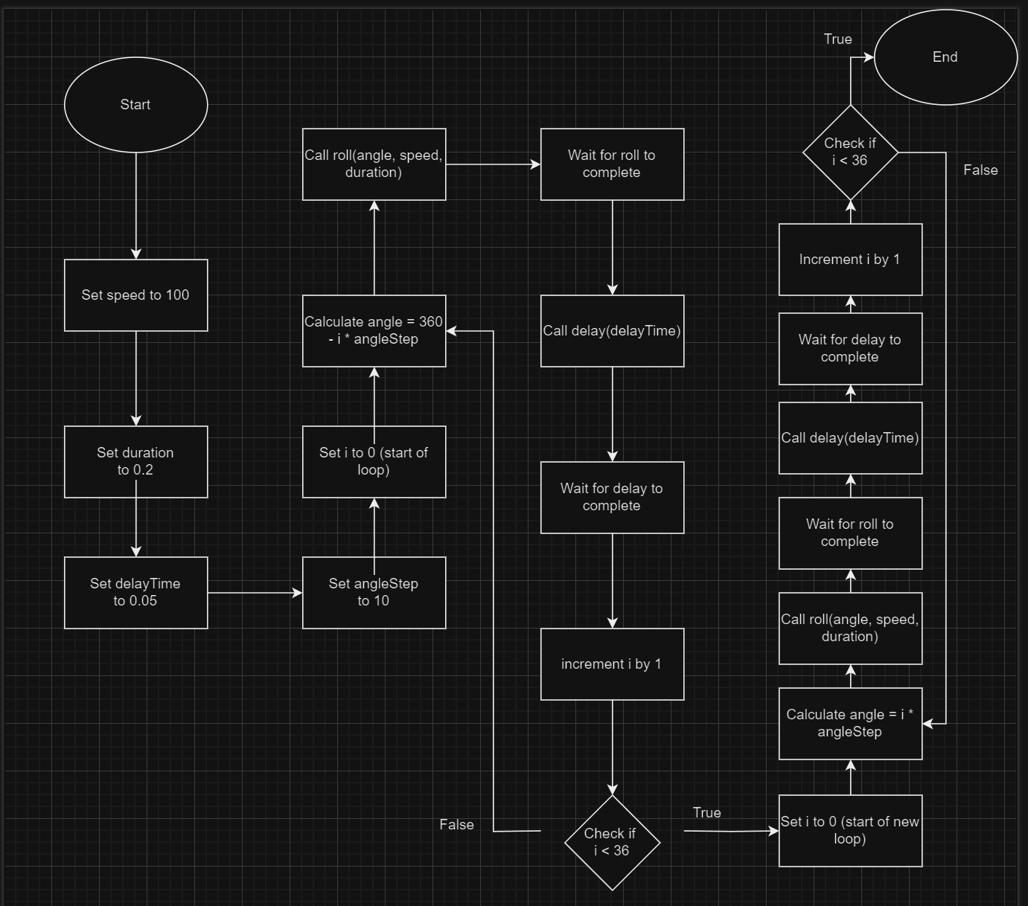

1. **Block Code**

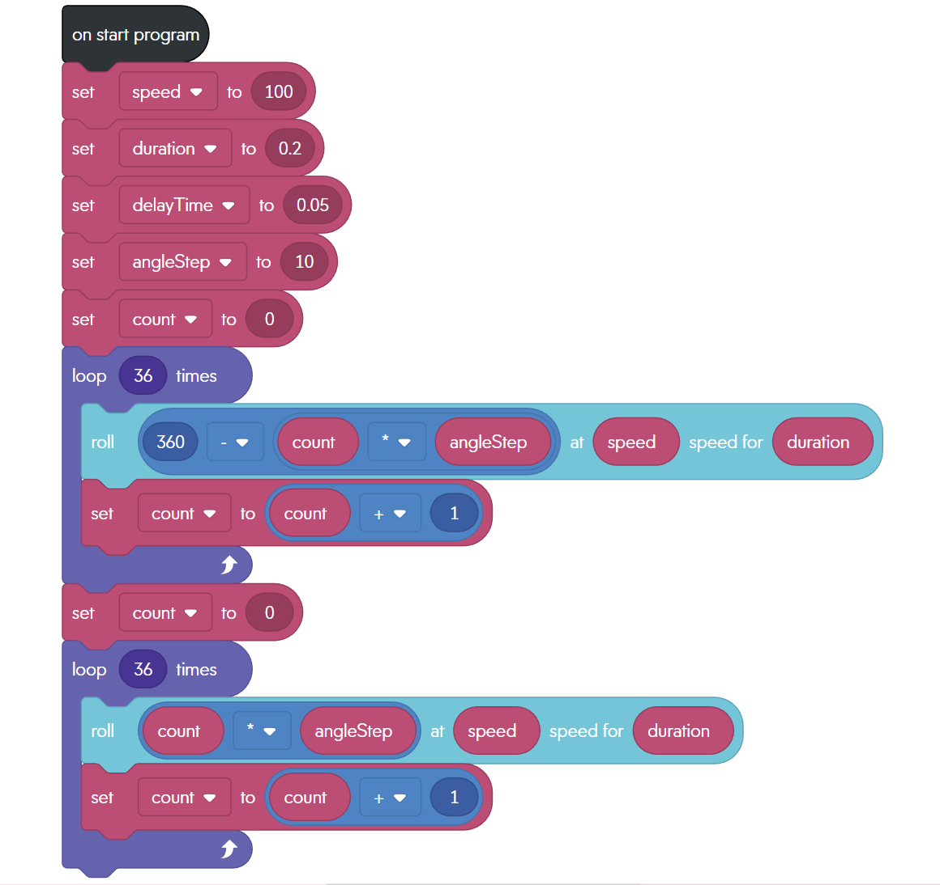

1. **Sensor Data**

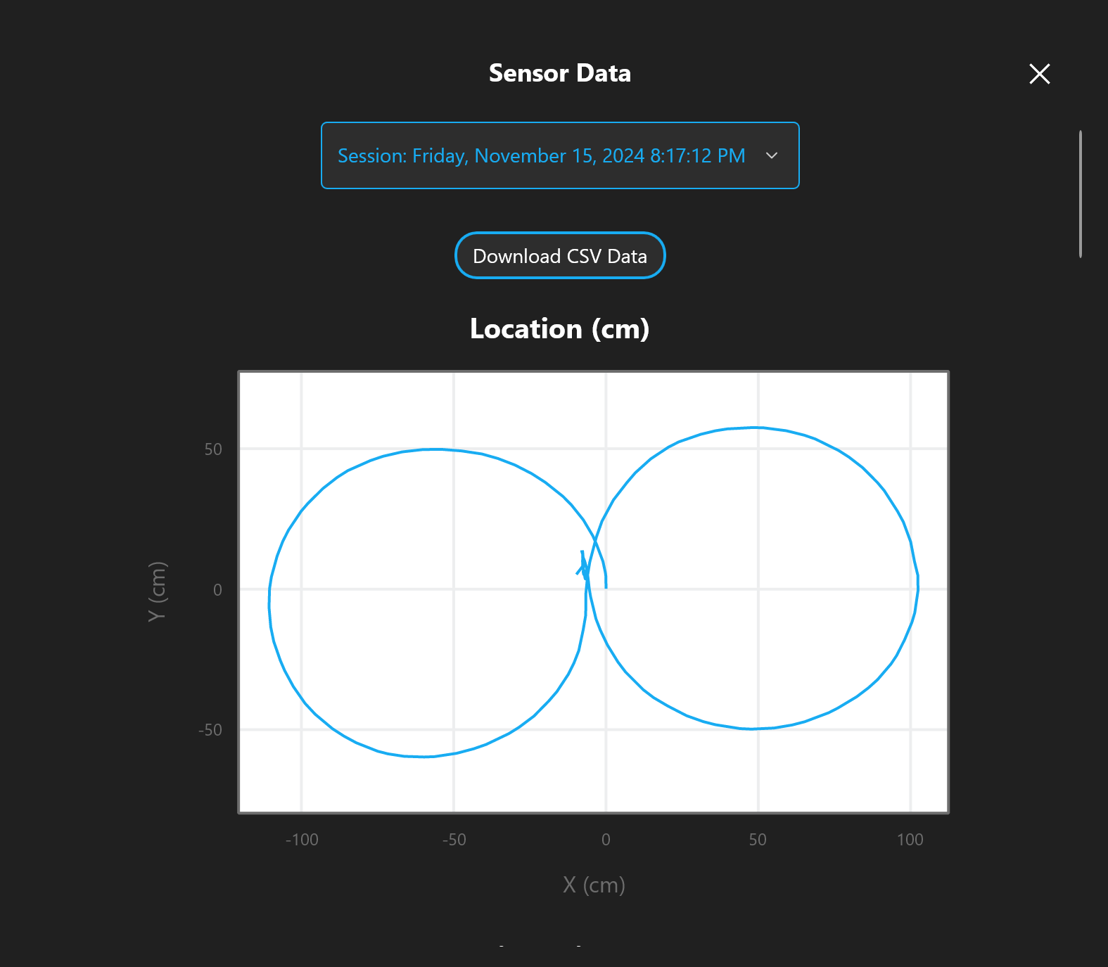

1. **Test Table**

| **Test Case** | **Description** | **Expected Outcome** | **Actual Outcome** | **Pass/Fail** |
| --- | --- | --- | --- | --- |
| TC1 | Go in a clockwise circle | Robot goes in a perfect clockwise circle | Robot went in a somewhat perfect clockwise circle | Pass |
| TC2 | Go in a counter-clockwise circle | Robot goes in a perfect counter-clockwise circle | Robot went in a somewhat perfect counter-clockwise circle | Pass |

1. **Staffing Plan**

| **Name** | **Title** | **Responsibilities** |
| --- | --- | --- |
| Isaac Sasson | Group leader | Submit project and create github |
| Bilal Shweb | Group member | Assist with the project and github |